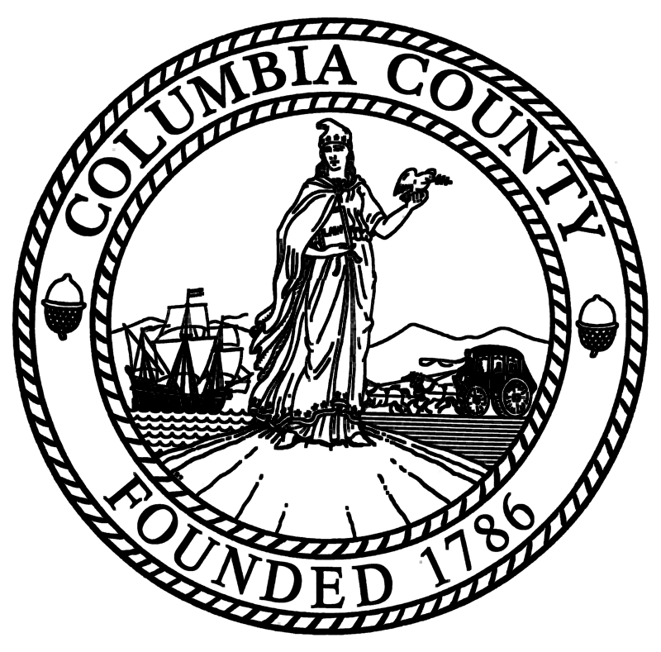 Columbia County
Board of Supervisors

Kelly S. Baccaro
Clerk

Angela L. Rothermel
Deputy Clerk

401 State Street
Hudson, New York 12534
Matt B. Murell
Chairman

Richard Keaveney
Deputy Chairman

Ronald Knott
Deputy Chairman

Telephone: 518-828-1527
Fax: 518-822-0684
www.ColumbiaCountyNY.com

Columbia County Opioid Epidemic Response Forum and Narcan Training on October 12th at the Germantown Town Hall
The Columbia County Department of Health is partnering with Columbia Pathways to Recovery and Catholic Charities’ Project Safe Point to provide Narcan training prior to the Columbia County Board of Supervisors 4th Opioid Epidemic Response Forum.
The 4th Forum will convene at 6:00 PM on Thursday October 12th at the Germantown Town Hall, 50 Palatine Park Road, Germantown, NY. The 1 hour Narcan training begins at 5:00 PM.
Narcan is a medication used to block the effects of opioids especially in overdose. Narcan can reverse an overdose due to opioids.
Columbia County Board of Supervisors Chairman Matt Murell states that, “this life saving drug has saved thousands of lives and is an important tool in our response to the nationwide heroin epidemic.”
Columbia County Sheriff Dave Bartlett has personally used Narcan to save the life of a Columbia County woman suffering from the effects of an overdose on heroin. “My department implemented the Narcan Response Program in 2014 and it has saved the lives of county residents. I encourage concerned parents to take advantage of this training opportunity,” said Sheriff Bartlett.
Germantown Town Supervisor Joel Craig encourages residents to attend the Narcan Training and the County Forum. “The Opioid Epidemic is taking a toll on all communities. This Forum is an opportunity for residents to learn about the many important services available to them in the County”, said Supervisor Craig.
A panel discussion of county officials, and community based service providers will discuss efforts their respective agencies engage in daily to address the crisis, focusing on:
- The County Response Plan
- What the county has done to this point to stem the crisis
- Available services

For details about the Columbia County Opioid Response Plan, available services, and to view a video of the previous Regional Forums please visit www.columbiacountyny.com.

